**Lab 6: Design 3 Alternatives for a Known Solution - Mobile UI using Adobe XD**

**1. Enter Your Name and Register Number:**

|  |
| --- |
| **Avatansh Awasthi (1947208)** |

**2. Enter the Domain Chosen:**

|  |
| --- |
| **Education** |

**3. Enter the Application Chosen:**

|  |
| --- |
| **Google Meet** |

**4. Finding the Right Solution to be Identified Problem (Questions)**

|  |  |  |
| --- | --- | --- |
| **S.No** | **Questions** | **Description** |
| **1** | **What are the key challenges?** | **To be able to access in-meet chat with ease.** |
| **2** | **What are the design alternatives?** | **Split Screen, Icon Button, Swipe Right.** |
| **3** | **What are the constraints?** | **Screen Space, Minimalistic Design.** |

**5. Enter the details of the alternative methods chosen for the proposal**

|  |  |  |  |  |
| --- | --- | --- | --- | --- |
| **S.No** | **Problem Identified** | **Alternative Solution 1** | **Alternative Solution 2** | **Alternative Solution 3** |
| **1** | **An issue in the Chatting in Google Meet –**  **To access the in meet chat we need to navigate through the kebab menu.** | **ICON Button-**  **Introduction of a button for quick access to the chat at the right top corner.** | **Swipe Right-**  **The standard way to go to chat in almost all applications is to swipe right on the main screen.** | **Split Screen-**  **To chat and see the content being shared simultaneously we can have a solution of having the shared screen and the chat window in a split-screen.** |

**6. Screenshot of the Existing Interface:**

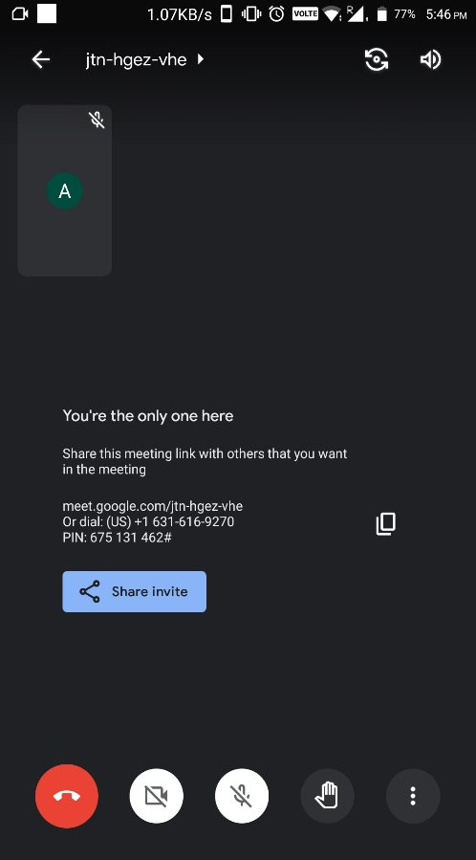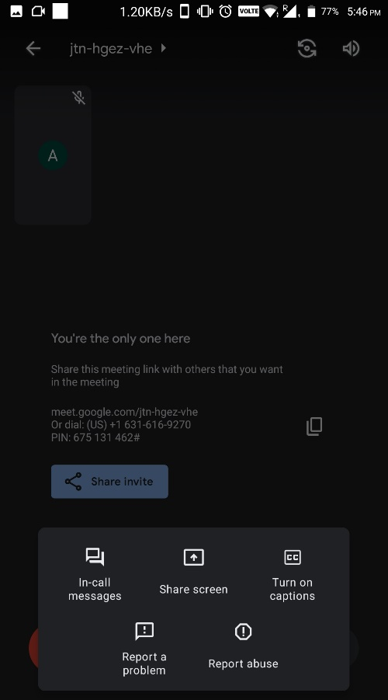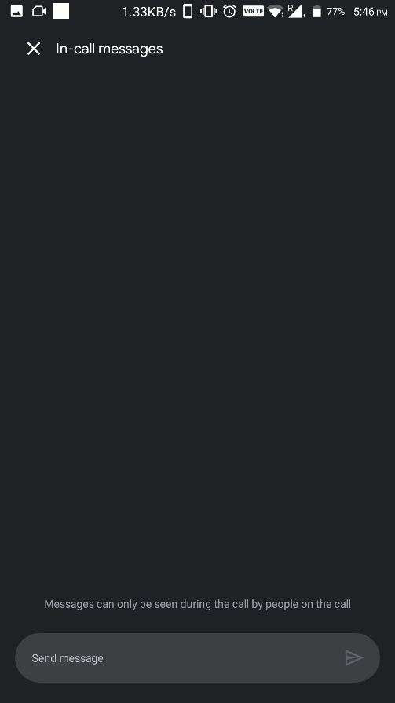

**7. Screenshot of the Design Proposed for the Existing Interfaces: (Draw 3 Scenarios)**

**Scenario 1:** Comment Icon on top right corner for easy and quick access to the chat window.

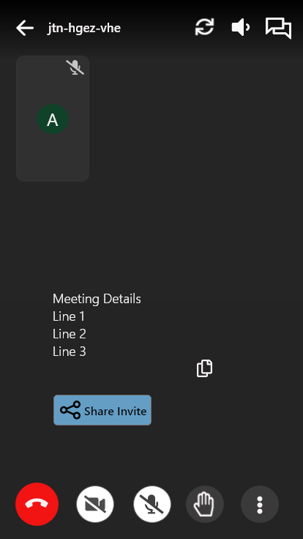

**Scenario 2:** We can simply swipe right on the main screen to get the access to chat window just like lost application nowadays provide this feature so that user need not worry about finding chat window.

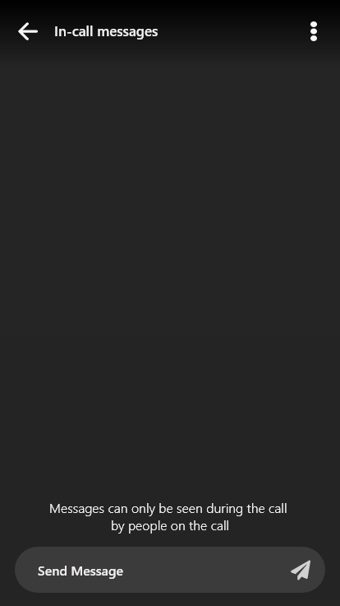

**Scenario 3:**  There are times when we need to see the main screen as someone is prsenting their screen and chat simultaneously. To tackle this we can have a split-screen between the chat window and the main screen, also I’ve given an option to drag and set what amount of screen can be split between the two screen and the design is as following:



